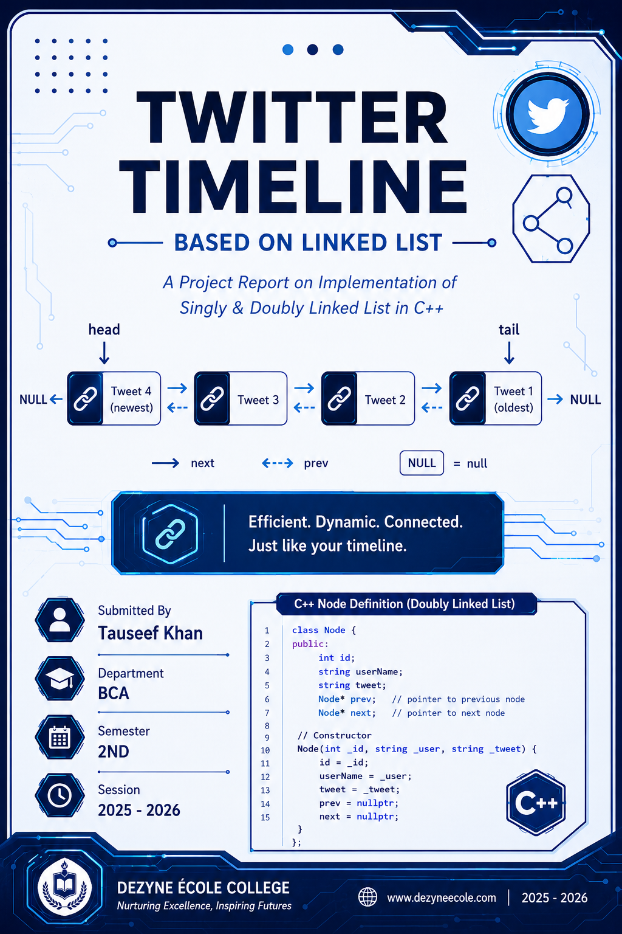

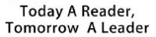


Title of Project

Twitter Timeline Based on Link List

Subject Name

Data Structure and C++

Submitted By

Tauseef Khan

Department – BCA

Semester – 2nd

Session – 2025-26

Project Report on

Twitter TimeLine Based on
Link List

Submitted to

Dezyne Ѐcole College

Towards the Partial Fulfilment of

2nd Semester

By

Tauseef khan



www.dezyneecole.com
2025-2026

Acknowledgement

We take this opportunity to express our sincere gratitude to Dezyne École College for providing us with the knowledge, resources, and guidance essential to the successful completion of this project.
Our deepest thanks to our respected Principal, Dr. Vinita Mathur, for her visionary leadership and continuous encouragement. Her commitment to academic excellence and student growth has been a constant source of motivation and pride.
We are equally thankful to all Mr. Tarun Sir for his consistent support, expert advice, and valuable insights that shaped our learning and helped us achieve this milestone.
Lastly, we extend heartfelt thanks to everyone who directly or indirectly contributed to the success of this project.
We are proud to be part of Dezyne École College, an institution that truly nurtures professionalism, innovation, and purpose.

With sincere appreciation,
Tauseef Khan
Department of BCA
Dezyne École College, Ajmer

Part 1: Introduction — What is a Linked List?
A Linked List is a linear data structure where elements (called nodes) are NOT stored in contiguous memory locations. Each node holds its data and one or two pointers — memory addresses — that link it to neighbouring nodes. The nodes can live anywhere in RAM; the pointers stitch them into a logical sequence.
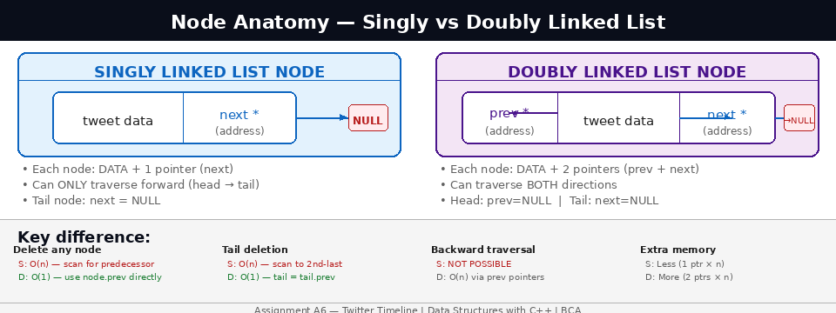

Real-World Context — Twitter Timeline
Twitter's home timeline shows tweets in reverse-chronological order — newest at the top, oldest at the bottom. Three operations dominate this system:
- Insert at head: A new tweet always goes at the very top. This must be instant — O(1).
- Delete from any position: Content moderation removes any tweet immediately — O(1).
- Traverse from head to tail: Displaying the timeline scrolls from newest to oldest — O(n).
These three needs define the Linked List — a data structure that does all three efficiently.

Singly vs Doubly — At a Glance
Property | Singly Linked List | Doubly Linked List
Pointers per node | 1 (NEXT only) | 2 (PREV + NEXT)
Traversal direction | Forward only (head → tail) | Both directions
Delete tail | O(n) — must scan to 2nd-last | O(1) — use tail.prev
Delete any node (with ptr) | O(n) — scan for predecessor | O(1) — both neighbours known
Extra memory | Less (1 ptr × n) | More (2 ptr × n = +8 bytes/node)
Typical use | Stacks, hash chaining, simple queues | Timelines, browsers, LRU cache, deques

Why Not an Array?
Operation | Array | Linked List | Twitter's Need
Insert at front | O(n) — shift all elements right | O(1) — rewire 2 pointers | New tweet on top — must be instant
Delete any element | O(n) — shift remaining elements | O(1) — rewire neighbours | Remove any tweet instantly
Access by index | O(1) — direct formula | O(n) — traverse from head | Not needed for sequential display
Dynamic size (grow) | Needs reallocation | Trivial — just add a node | Tweet count is unpredictable
Search | O(n) linear, O(log n) binary | O(n) linear only | Both require traversal for unsorted data

Part 2: Singly Linked List — All Operations

Node Structure & Memory Representation
In a singly linked list, each node stores data and ONE pointer — next — which holds the memory address of the following node. The last node's next = NULL. We maintain a head pointer to always find the start, and optionally a tail pointer for efficient end-access.

C++ struct:
Memory layout example:
head → [Tweet4 | 0x3A10] → [Tweet3 | 0x1F40] → [Tweet2 | 0x7C80] → [Tweet1 | NULL]
at 0x2B00 at 0x3A10 at 0x1F40 at 0x7C80
↑ newest ↑ oldest (tail)

Nodes are SCATTERED in RAM — not consecutive like an array.
The only way to reach Tweet2 is: start at head, follow next, follow next, arrive.

Insert at Head – O (1)
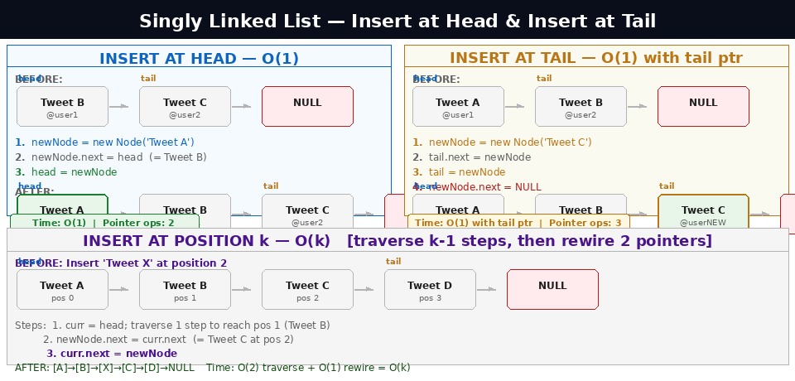

Concept
The newest tweet always goes at the top of the timeline. Head insertion achieves this in exactly 2 pointer operations — always O(1) regardless of how many tweets already exist.

Step-by-Step Algorithm
- Create new node: NODE* TEMP = new NODE(TID, UName, UTweet); — allocates heap memory, sets next = NULL.
- Connect forward: TEMP->NEXT = START; — new node now points to the current head (will become 2nd node).
- Move head pointer: head = newNode; — head now refers to the new node.
- Handle empty list: If the list was empty, also set tail = newNode;
- Increment counter: size++;

int insertNode(int opr) // opr=1: At Beginning {
NODE* TEMP = new NODE(TID, UName, UTweet);

if (START == nullptr) { // empty list
START = END = TEMP;
} else {
TEMP->NEXT = START; // Step 2: link forward
head = newNode; // Step 3: advance head
}
countNode++;
}

// Example trace:
// Before: head → [B] → [C] → NULL
// newNode.next = B (newNode now points to B)
// head = newNode
// After: head → [A] → [B] → [C] → NULL Time: O(1)
Why O(1)? No loop, no traversal. The same 2 pointer operations run whether the list has 3 nodes or 3 million nodes.

2.3 Insert at Tail - O (1) with tail pointer
Without tail pointer: Must traverse all n nodes to reach the last one, then append. Cost = O(n).
With tail pointer (always recommended): Directly access tail, attach new node, advance tail. Cost = O(1).

Step-by-Step Algorithm (with tail pointer)
- Create new node: NODE* TEMP = new NODE(TID, UName, UTweet); — newNode->next = NULL.
- Handle empty list: If head == NULL: START = END = TEMP; return.
- Connect: tail->next = newNode; — current tail now points to the new node.
- Advance tail: tail = newNode; — tail pointer moves to the new last node.
- Increment counter: size++;

int insertNode(int opr) // opr=2: At End {
NODE* TEMP = new NODE(TID, UName, UTweet);

if (START == nullptr) {
START = END = TEMP;
} else {
tail->next = newNode; // current tail points forward
tail = newNode; // tail advances to new node
}
countNode++;
}

// Before: head→[A]→[B]→NULL tail=B
// tail.next = newNode (= C)
// tail = C
// After: head→[A]→[B]→[C]→NULL tail=C Time: O(1)

2.4 Insert at Position k - O(k)
Three sub-cases
- k = 0: Same as insertAtHead() — O(1).
- k = size (last position + 1): Same as insertAtTail() — O(1).
- 0 < k < size (middle): Traverse k-1 steps to find the predecessor node, then rewire 2 pointers.

Step-by-Step Algorithm for Middle Insert
- Create newNode.
- Start curr = head; traverse k-1 steps: for(int i=0; i<k-1; i++) curr = curr->next;
- newNode->next = curr->next; — new node points to what curr was pointing to.
- curr->next = newNode; — curr now points to new node.
- size++;

void insertAtPosition(int k, string text, string user) {
if (k <= 0) { insertAtHead(text, user); return; }
if (k >= size) { insertAtTail(text, user); return; }

NODE* TEMP = new NODE(TID, UName, UTweet);
NODE* curr = START;

for (int i = 0; i < k-1; i++) // traverse k-1 steps
curr = curr->next;

newNode->next = curr->next; // new node points past curr
curr->next = newNode; // curr points to new node
countNode++;
}

// Insert 'X' at pos 2 in [A]→[B]→[C]→[D]:
// curr = B (after 1 step, since k-1=1)
// X.next = C ; B.next = X
// Result: [A]→[B]→[X]→[C]→[D] Time: O(2) = O(k)

2.5 Delete Operations - 3 Cases
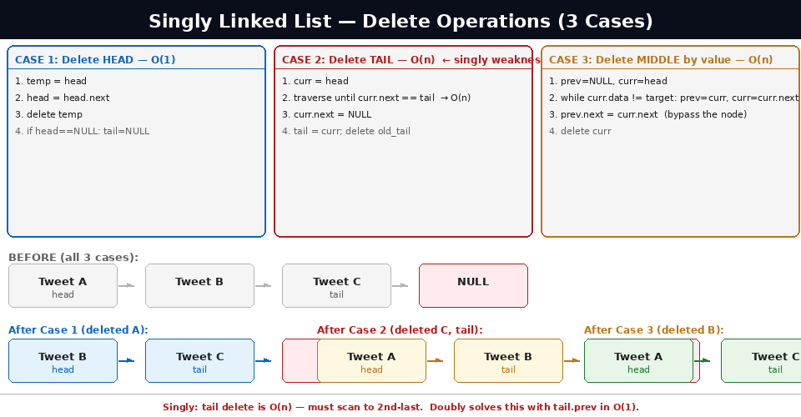

Case 1 — Delete Head — O (1)
Moving the head pointer one step forward effectively removes the first node. No traversal needed.
- temp = head; — save the node to free later.
- head = head->next; — head now points to the 2nd node (new head).
- If head != NULL: it was a single-node list: set tail = NULL;
- delete temp; — free heap memory.
- size--;

Case 2 — Delete Tail — O(n) ← Singly's Weakness
Problem: To delete the tail we must update the second-to-last node's next pointer to NULL. In a singly linked list the only way to find that node is to traverse from head — O(n). This is why doubly linked lists are preferred when tail deletion is frequent.
- Start curr = head; traverse until curr->next == tail;
- curr->next = NULL; — second-to-last now terminates the list.
- delete tail; then tail = curr;
- size--;

Case 3 — Delete Middle Node by Value — O(n)
Find the target node and its predecessor simultaneously using two pointers, then bypass the target.
- prev = NULL; curr = head;
- Traverse: while curr != NULL and curr->data != target: prev = curr; curr = curr->next;
- If curr == NULL: value not found — return.
- prev->next = curr->next; — predecessor skips over the target node.
- If curr == tail: tail = prev; — update tail pointer.
- delete curr; countNode--;

int deleteNode(int opr) // opr=3: By Value {
if (!START) { cout << "Empty list"; return; }

// Special case: deleting head
if (START->TWEET == target) { deleteHead(); return; }

NODE* prev = nullptr;
NODE* curr = START;

while (curr != nullptr && curr->TWEET != target) {
prev = curr;
curr = curr->next;
}

if (curr == nullptr) { cout << "Not found"; return; }

prev->next = curr->next; // bypass the node
if (curr == tail) tail = prev; // update tail if needed
delete curr;
countNode--;
}

2.6 Traversal - O(n)
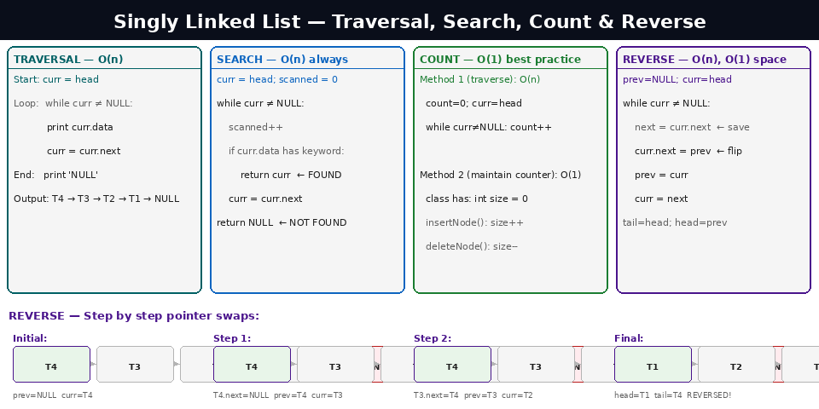

Concept
Traversal visits every node exactly once, following next pointers from head until NULL. This is how Twitter renders your timeline from top to bottom — each tweet displayed in order.
- curr = head; — start at newest tweet.
- Loop: while (curr != nullptr) — stop when we fall off the end.
- Inside loop: process curr->data; then curr = curr->next;

void showNode() {
NODE* curr = START;
int position = 1;

while (curr != nullptr) {
cout << position << ". [@" << curr->UNAME << "] "
<< curr->TWEET
<< curr->TWEET << "] -->" << endl;
curr = curr->next; // follow next pointer
position++;
}
cout << "NULL (end of timeline)" << endl;
}
// Time: O(n) | Space: O(1) — only one curr pointer variable
Critical exam point: Always check curr != nullptr BEFORE accessing curr->data. Accessing a NULL pointer causes a segmentation fault (crash). This is the #1 beginner error in linked list programs.

2.7 Search by Keyword - O(n)
Why O(n) only: Linked lists have no index formula. To find a node you must start at head and examine each node one by one. Best case O(1) if found at head. Worst case O(n) if at tail or absent.
Why binary search is impossible: Binary search requires jumping to the middle element. In a linked list, reaching node i requires following i pointers from head — O(i). So finding the middle costs O(n/2), making binary search O(n log n) — worse than linear O(n).

int searchTweetInNode() {
NODE* curr = START;
int scanned = 0;

while (curr != nullptr) {
scanned++;
if (curr->TWEET.find(keyword) != string::npos) {
cout << "Found after " << scanned << " nodes" << endl;
return curr; // found — return pointer to node
}
curr = curr->next;
}
cout << "Not found — scanned all " << scanned << " nodes (O(n))" << endl;
return nullptr;
}

2.8 Count Nodes - O (1) Best Practice
Approach |  | Algorithm | Time | Recommendation
Traverse and count |  | curr=head; while curr≠NULL: count++; curr=curr.next | O(n) per call | Avoid for frequent calls
Maintain size counter |  | size++ on insert, size-- on delete, getCount() returns size | O(1) per call | Always use this approach
// Maintain a 'size' member variable in the class
int getCount() { return countNode; } // O(1) — just return the variable

// Increment whenever you insert
void insertAtHead(string t, string u) { /* ... */; countNode++; }

// Decrement whenever you delete
int deleteNode(int opr) // opr=1: Beginning { /* ... */; countNode--; }

2.9 Reverse the List - O(n) Time, O (1) Space
Concept
Reversing a singly linked list flips all next pointers so the old tail becomes the new head. The key is maintaining three pointers — prev, curr, next_node — so we never lose our place.
No extra list: The reversal happens in-place by redirecting existing pointers. Space = O(1) — a major advantage over creating a new reversed copy.

Three-Pointer Algorithm
- Initialise: prev = nullptr; curr = head;
- Loop: while (curr != nullptr)
- Save next: NODE* nextNode = curr->next;
- Flip pointer: curr->next = prev; ← this is the reversal
- Advance: prev = curr; curr = nextNode;
- After loop: tail = head; then head = prev; ← prev is now the old tail = new head

void reverseList() {
NODE* prev = nullptr;
NODE* curr = START;
NODE* nextNode = nullptr;

END = START; // old START will become new tail

while (curr != nullptr) {
nextNode = curr->next; // save — we're about to overwrite it
curr->next = prev; // FLIP: point backward
prev = curr; // advance prev
curr = nextNode; // advance curr
}
START = prev; // prev = old END = new START
}

// Trace for [T4]→[T3]→[T2]→[T1]→NULL:
// Iter 1: T4.next = NULL prev=T4 curr=T3
// Iter 2: T3.next = T4 prev=T3 curr=T2
// Iter 3: T2.next = T3 prev=T2 curr=T1
// Iter 4: T1.next = T2 prev=T1 curr=NULL (stop)
// head = T1 → [T1]→[T2]→[T3]→[T4]→NULL Time: O(n), Space: O(1)

Part 3: Doubly Linked List — All Operations

What the prev Pointer Adds
A doubly linked list adds one extra pointer — prev — to every node. This single addition costs 8 bytes per node on a 64-bit system but unlocks three major advantages:
- O(1) delete of any node — both neighbours are immediately accessible via prev and next. No scanning needed.
- O(1) tail deletion — tail.prev gives the second-to-last node directly. No traversal.
- Backward traversal — start at tail, follow prev pointers. Impossible in singly linked lists.

C++ Node Structure for Doubly Linked List
class NODED {
string TWEET;
string UNAME;
string ID;
NODED* prev; // ← NEW: points to previous (newer) tweet
NODED* next; // points to next (older) tweet

NODED(string x, string y, string z) { ID = x;
ID = x; UNAME = y; TWEET = z; PREV = nullptr; NEXT = nullptr;
prev = nullptr; // NULL initially
next = nullptr;
}
};

// Memory layout:
// NULL ← [T4 | prev←→next] ↔ [T3 | prev←→next] ↔ [T2 | prev←→next] ↔ [T1] → NULL
// ↑ head ↑ tail
// head.prev = NULL | tail.next = NULL

3.1 Insert at Head - O (1)
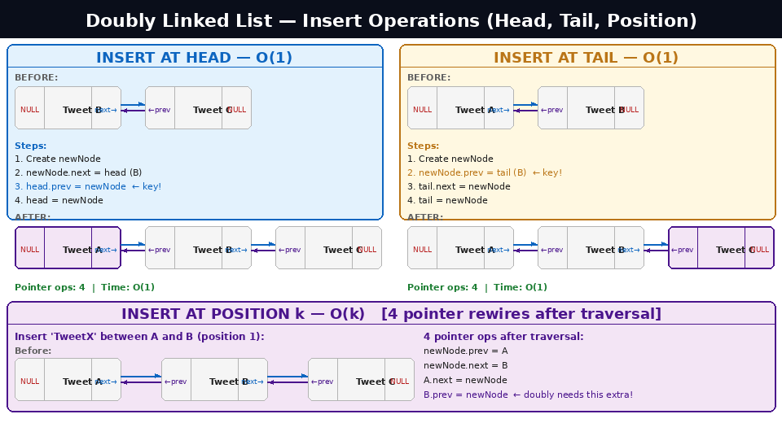

Extra Step vs Singly
Compared to singly insertion at head, doubly adds one step: setting the old head's prev pointer back to the new node.

Algorithm — 4 pointer operations
- Create: NODED* TEMP = new NODED(TID, UName, UTweet); — prev=NULL, next=NULL.
- If empty: START = END = TEMP; return.
- Connect forward: TEMP->NEXT = START; — new node points to old head.
- Connect backward: head->prev = newNode; — old head points BACK to new node. ← extra step vs singly!
- Advance head: head = newNode;
- size++;

int insertNode(int opr) // opr=1: At Beginning {
NODED* TEMP = new NODED(TID, UName, UTweet);

if (!START) { START = END = TEMP; countNode++; return; }

TEMP->NEXT = START; // 1. new node → old head
START->PREV = TEMP; // 2. old head ← new node (DOUBLY key step)
START = TEMP; // 3. advance head
// newNode->prev stays NULL — it is the new head
countNode++;
}

3.2 Insert at Tail – O (1)
Always O(1): Doubly linked lists always maintain a tail pointer. Appending is direct — no traversal required in either the empty or non-empty case.

Algorithm — 4 pointer operations
- Create: NODED* TEMP = new NODED(TID, UName, UTweet);
- If empty: START = END = TEMP; return.
- Connect backward: TEMP->PREV = END; — new node looks BACK at current tail.
- Connect forward: tail->next = newNode; — current tail points forward to new node.
- Advance tail: tail = newNode;
- size++;

int insertNode(int opr) // opr=2: At End {
NODED* TEMP = new NODED(TID, UName, UTweet);

if (!END) { START = END = TEMP; countNode++; return; }

TEMP->PREV = END; // 1. new node ← current tail
END->NEXT = TEMP; // 2. current tail → new node
END = TEMP; // 3. tail advances
// newNode->next stays NULL — it is the new tail
countNode++;
}

3.3 Insert at Position k -O(k)
Middle case — 4 pointer rewires (vs 2 in singly)
Traverse to position k-1 (same as singly), but now must wire FOUR pointers: both neighbours' prev and next must be updated.

// Insert between node A (at pos k-1) and node B (at pos k)
NODED* A = /* traverse to pos k-1 */;
NODED* B = A->next;

newNode->prev = A; // new node looks back to A
newNode->next = B; // new node looks forward to B
A->next = newNode; // A now points to new node
if (B) B->prev = newNode; // B now points back to new node
else tail = newNode; // inserting at end: update tail

// Result: NULL ← [A] ↔ [NEW] ↔ [B] → NULL
// Time: O(k) traverse + O(1) rewire = O(k)

3.4 Delete Head – O (1)
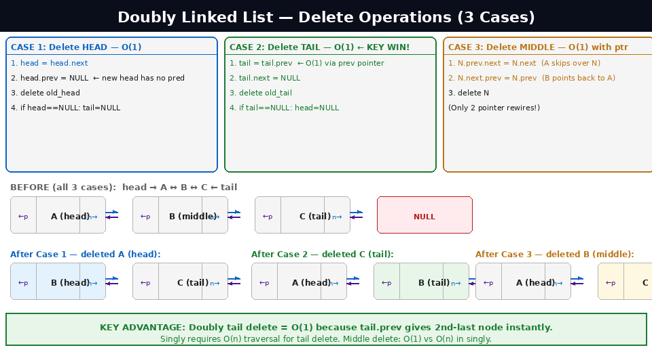

Algorithm
- Check: If head == NULL: empty list, return.
- Save: NODED* TEMP = START;
- Advance head: head = head->next;
- If head != NULL: START->PREV = nullptr; — new head has no predecessor.
- Else (list now empty): tail = nullptr;
- Free: delete temp; countNode--;

3.5 Delete Tail – O (1) ★ Key Advantage Over Singly
Why This is Doubly's Key Advantage
In a singly linked list, deleting the tail requires O(n) traversal to find the second-to-last node (which must have its next set to NULL). In a doubly linked list, tail.prev ALREADY points to the second-to-last node — O(1), no scanning!

Algorithm — 3 pointer operations
- Check: If tail == NULL: empty list, return.
- Save: NODED* TEMP = END;
- Advance tail BACKWARD: END = END->PREV; ← ONLY possible because of the prev pointer!
- If tail != NULL: tail->next = nullptr; — new tail has no successor.
- Else (list now empty): head = nullptr;
- delete temp; countNode--;

int deleteNode(int opr) // opr=2: End {
if (!END) return;

NODED* TEMP = END;
END = END->PREV; // O(1) — prev pointer does the work

if (tail) tail->next = nullptr; // new tail's next = NULL
else head = nullptr; // list became empty

delete temp;
countNode--;
}
// Singly equivalent would need: while(curr->next != tail) curr=curr->next; → O(n)

3.6 Delete Middle Node - O (1) with pointer / O(n) if search required
The Biggest Advantage
If you already have a direct pointer to the node to delete, O(1) is achievable because both neighbours are accessible via prev and next. Just 2 rewires bypass the node completely.

Algorithm — 2 pointer rewires
- Check edge cases: if N == head → call deleteHead(); if N == tail → call deleteTail().
- A.next = N.next: N->prev->next = N->next; — predecessor skips over N.
- B.prev = N.prev: N->next->prev = N->prev; — successor points back past N.
- delete N; countNode--;

int deleteNode(int opr) // opr=3: Middle {
if (!N) return;
if (N == head) { deleteHead(); return; }
if (N == tail) { deleteTail(); return; }

// Middle node — both neighbours already known!
N->prev->next = N->next; // A skips over N → points to B
N->next->prev = N->prev; // B points back past N → points to A
delete N;
countNode--;
// Only 2 pointer rewires — O(1) — NO SCANNING NEEDED
}

// Singly equivalent would need O(n) scan to find N's predecessor.

3.7 Forward & Backward Traversal - O(n) each
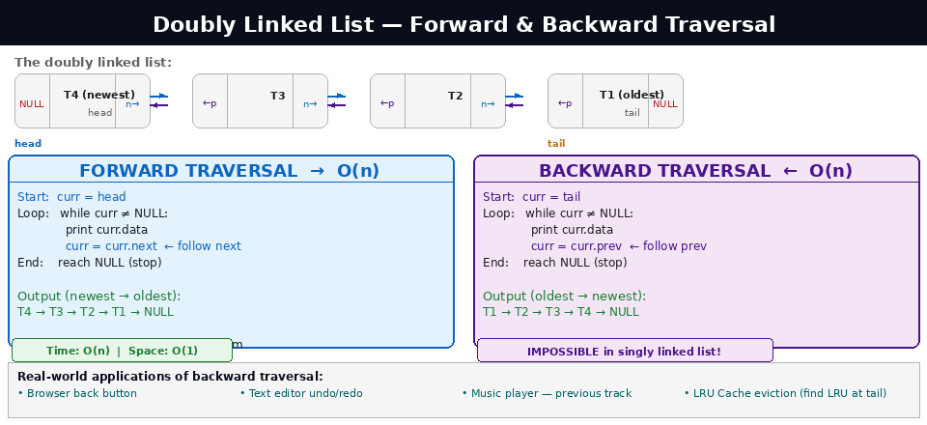

Forward Traversal (Newest → Oldest)
Identical to singly traversal. Start at head, follow next pointers. This is how Twitter renders your timeline top-to-bottom.
void showNode() // Forward {
NODED* curr = head; // start at newest tweet
while (curr != nullptr) {
cout << "[@" << curr->UNAME << "] " << curr->TWEET << endl;
curr = curr->next;
}
cout << "NULL" << endl;
}
// Output: T4 → T3 → T2 → T1 → NULL (newest first)

Backward Traversal (Oldest → Newest) ← Impossible in Singly
Unique to doubly linked lists. Start at tail, follow prev pointers. This direction is physically impossible in a singly linked list because there is no prev pointer.
void showNode() // Backward {
NODED* curr = tail; // start at OLDEST tweet
while (curr != nullptr) {
cout << "[@" << curr->UNAME << "] " << curr->TWEET << endl;
curr = curr->prev; // follow PREV pointer
}
cout << "NULL" << endl;
}
// Output: T1 → T2 → T3 → T4 → NULL (oldest first)
// Use case: 'Show oldest tweets first' view on Twitter

Real-World Applications of Backward Traversal
Application | How Backward Traversal is Used
Browser back button | Navigate history in reverse (most recent → oldest visited)
Text editor undo/redo | Move backward through change history to undo actions
Music player Previous Track | Go backward through the playlist
LRU Cache eviction | Tail is LRU item — accessed via backward from end, evicted O(1)
Twitter / Social Media | Show thread in chronological order (oldest reply first)

Part 4: Complete Complexity Comparison & Exam Guide

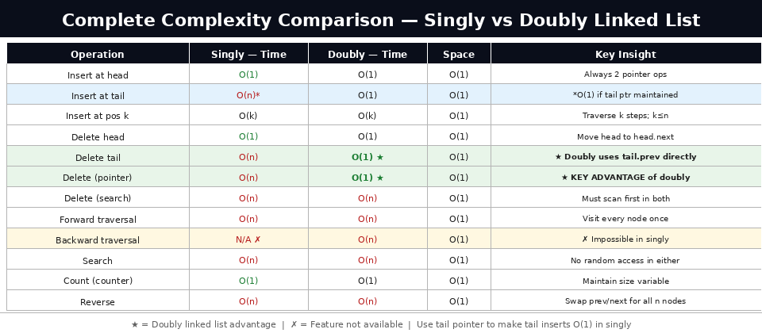

4.1 Full Complexity Table
Operation | Singly Time | Doubly Time | Space | Notes
Insert at head | O(1) | O(1) | O(1) | Singly: 2 ops | Doubly: 4 ops
Insert at tail | O(n) / O(1)* | O(1) | O(1) | *O(1) with tail pointer maintained
Insert at position k | O(k) | O(k) | O(1) | Traverse k steps; doubly needs 4 rewires
Delete head | O(1) | O(1) | O(1) | Move head forward
Delete tail | O(n) | O(1) ★ | O(1) | ★ DOUBLY KEY ADVANTAGE: use tail.prev
Delete with pointer | O(n) | O(1) ★ | O(1) | ★ Doubly: both neighbours known instantly
Delete by value | O(n) | O(n) | O(1) | Must search first; unlink is O(1)
Forward traversal | O(n) | O(n) | O(1) | Visit every node once
Backward traversal | N/A — impossible | O(n) | O(1) | Only doubly can go backwards
Search | O(n) | O(n) | O(1) | Binary search impossible — no random access
Count (counter var) | O(1) | O(1) | O(1) | Maintain size variable — always do this
Reverse | O(n) | O(n) | O(1) | Swap next/prev for all n nodes in-place

4.2 When to Use Which?
Use Case | Best Choice | Reason
Twitter timeline, feed | Doubly | O(1) delete anywhere, both-direction traversal
Browser back/forward | Doubly | Traverse both directions, O(1) add/remove ends
Undo/Redo system | Doubly | Walk backward and forward through actions
LRU Cache | Doubly + HashMap | O(1) delete any node when cache is full
Simple stack (LIFO) | Singly | Only need push/pop at head, less memory
Hash table chaining | Singly | Simple forward-only chain, less overhead
Print job queue (FIFO) | Singly + tail ptr | Enqueue at tail O(1), dequeue at head O(1)
Playlist with prev/next | Doubly | Song navigation in both directions

4.3 Key Exam Questions & Answers

Q1: Why is inserting at head O(1) in a linked list but O(n) in an array?
A: An array stores elements consecutively in memory. Inserting at index 0 requires shifting ALL existing elements one position right — that is n copy operations. A linked list has no such constraint — we just create a new node and rewire 2 pointers (newNode.next = head, head = newNode). These 2 operations are the same whether the list has 3 nodes or 3 million.

Q2: Why is singly tail deletion O(n) but doubly tail deletion O(1)?
A: To delete the tail we must update the second-to-last node's next pointer to NULL. In a singly linked list the only way to find that node is to traverse from head — O(n) steps. In a doubly linked list, tail.prev ALREADY holds the address of the second-to-last node. We access it in O(1) with no scanning needed.

Q3: Why is binary search impossible on a linked list?
A: Binary search requires O(1) access to the middle element (arr[mid]). In a linked list there is no index formula — finding node i requires following i pointers from head, costing O(i). So finding the middle costs O(n/2), making binary search O(n log n) in total — worse than just scanning linearly at O(n). Always use linear search on linked lists.

Q4: What is the space complexity of reversing a linked list?
A: O(1) — the three-pointer algorithm (prev, curr, nextNode) reverses the list in-place by redirecting existing pointers. No extra list or array is created. All n pointer rewires happen within the same memory nodes that already exist.

Q5: A node N is to be deleted from a doubly linked list. How many pointer operations are needed if you already have a pointer to N?
A: Exactly 2 operations: (1) N.prev.next = N.next — the predecessor skips over N. (2) N.next.prev = N.prev — the successor points back past N. Both neighbours are immediately accessible through N's own pointers, so no scanning is needed. Time = O(1).

4.4 Common Mistakes to Avoid in Exams

- Mistake 1 — NULL pointer access: Accessing curr->data without first checking curr != NULL. Always check for NULL before dereferencing any pointer.
- Mistake 2 — Forgetting tail pointer: Writing insert at tail as O(n) when a tail pointer makes it O(1). Always assume the class maintains both head and tail.
- Mistake 3 — Missing prev update in doubly: When inserting between A and B, forgetting B.prev = newNode. All 4 pointers must be wired.
- Mistake 4 — Not updating tail on delete: If you delete the current tail node (middle delete of last node), forgetting to update the tail pointer leaves a dangling pointer.
- Mistake 5 — Memory leak: Every node created with new must eventually be freed with delete. Forgetting delete in the destructor causes memory leaks.
- Mistake 6 — Claiming O(log n) search: Linked lists cannot do binary search. Search is always O(n). Never write O(log n) for linked list search.

4.5 Summary — The Complete Picture

Assignment 6 — Quick Reference
Twitter use case: Doubly linked list. New tweets insert at head in O(1). Any tweet deletes in O(1). Timeline scrolls forward via next, backward via prev.
Singly operations: Insert head O(1), insert tail O(1)*, insert pos O(k), delete head O(1), delete tail O(n), delete middle O(n), traversal O(n), search O(n), count O(1)*, reverse O(n).
Doubly operations: Insert head O(1), insert tail O(1), insert pos O(k), delete head O(1), delete tail O(1)★, delete middle O(1)★ with ptr, forward O(n), backward O(n).
★ marks doubly's advantages. The price: 8 extra bytes per node for the prev pointer.
The fundamental trade-off: Arrays give O(1) random access but O(n) insert/delete. Linked lists give O(1) insert/delete at known positions but O(n) access. Choose based on which operation is most frequent in your application.

SOURCE CODE
/*
============================================================
TWEET MANAGER — BCA 1st Year Project
Data Structure: Singly & Doubly Linked List
Author: Tauseef Khan
Description: A menu-driven C++ program that manages tweets using both Singly and Doubly
Linked Lists. Each tweet stores:
- Tweet ID (auto-generated)
- Username
- Tweet content
============================================================
*/

#include<iostream>
#include<conio.h>
#include<string>
using namespace std;

// ============================================================
// SECTION 1 : SINGLY LINKED LIST
// ============================================================

/*
NODE class for Singly Linked List.
Each node holds tweet data and a pointer to the NEXT node only.
*/
class NODE
{
public:
string ID; // Tweet ID e.g. "TWEET1001"
string UNAME; // Username
string TWEET; // Tweet content
NODE *NEXT; // Pointer to next node

NODE(string x, string y, string z)
{
ID = x;
UNAME = y;
TWEET = z;
NEXT = nullptr;
}
};

/*
LinkList class implements all Singly Linked List operations:
- Insert at Beginning / End / Given Position
- Delete from Beginning / End / Given Position
- Traversal (display all tweets)
- Search tweets by username
- Count total nodes
*/
class LinkList
{
public:
string TID;
int TCNT;
string UName, UTweet;
NODE *START, *END;
int countNode;

// Constructor — initialises an empty list
LinkList()
{
TCNT = 1001;
countNode = 0;
START = nullptr;
END = nullptr;
}

// --------------------------------------------------------
// Input helper — reads username and tweet from user
// --------------------------------------------------------
void getData()
{
TID = "TWEET" + to_string(TCNT);
cout << "\nAuto-generated TID -- " << TID << endl;
cout << "Enter User Name -- ";
getline(cin, UName);
cout << "Enter Tweet -- ";
getline(cin, UTweet);
}

// --------------------------------------------------------
// Continue-check menu shown after every operation
// --------------------------------------------------------
char continueCheck()
{
char c;
cout << "\n\nWhat would you like to do?\n";
cout << "1. Continue with Same Operation\n";
cout << "2. Go to Previous Menu\n";
cout << "3. Go to Main Menu\n";
cout << "4. Exit\n";
c = getch();
if (c == '4')
{
thanksLine();
exit(0);
}
return c;
}

// --------------------------------------------------------
// INSERT NODE
// opr = 1 : At Beginning
// opr = 2 : At End
// opr = 3 : At Given Position
// --------------------------------------------------------
int insertNode(int opr)
{
system("cls");

if (opr == 1)
{
cout << "\n\n--- Insert At Beginning ---\n\n";
getData();
NODE *TEMP = new NODE(TID, UName, UTweet);
if (TEMP == nullptr)
{
cout << "Insufficient Memory!\n";
return 0;
}
if (START == nullptr)
END = START = TEMP;
else
{
TEMP->NEXT = START;
START = TEMP;
}
countNode++;
TCNT++;
cout << "\nTweet inserted at beginning successfully!\n";
}
else if (opr == 2)
{
cout << "\n\n--- Insert At End ---\n\n";
getData();
NODE *TEMP = new NODE(TID, UName, UTweet);
if (TEMP == nullptr)
{
cout << "Insufficient Memory!\n";
return 0;
}
if (START == nullptr)
END = START = TEMP;
else
{
END->NEXT = TEMP;
END = TEMP;
}
countNode++;
TCNT++;
cout << "\nTweet inserted at end successfully!\n";
}
else if (opr == 3)
{
cout << "\n\n--- Insert At Given Position ---\n\n";
cout << "Total existing nodes: " << countNode << "\n\n";
int pos;
getData();
cout << "Enter Position (1 to " << countNode + 1 << ") -- ";
cin >> pos;
cin.ignore();

if (pos < 1 || pos > countNode + 1)
{
cout << "Invalid position!\n";
return 0;
}

NODE *TEMP = new NODE(TID, UName, UTweet);
if (TEMP == nullptr)
{
cout << "Insufficient Memory!\n";
return 0;
}

if (START == nullptr || pos == 1)
{
TEMP->NEXT = START;
START = TEMP;
if (END == nullptr) END = TEMP;
}
else
{
NODE *TEMP1 = START;
for (int i = 2; i < pos; i++)
TEMP1 = TEMP1->NEXT;

TEMP->NEXT = TEMP1->NEXT;
TEMP1->NEXT = TEMP;
if (TEMP1 == END)
END = TEMP;
}
countNode++;
TCNT++;
cout << "\nTweet inserted at position " << pos << " successfully!\n";
}

char c = continueCheck();
if (c == '1') insertNode(opr);
else if (c == '2') insertionOperation();
else if (c == '3') MainMenu();
return 0;
}

// --------------------------------------------------------
// DISPLAY / TRAVERSE all tweets
// --------------------------------------------------------
void showNode()
{
system("cls");
cout << "\n\n--- Singly Linked List Traversal ---\n\n";
if (START == nullptr)
{
cout << "HEAD --> NULL\n\nList is empty!\n";
return;
}
cout << "HEAD --> ";
NODE *TEMP = START;
while (TEMP != nullptr)
{
cout << "[" << TEMP->ID << " | "
<< TEMP->UNAME << " | "
<< TEMP->TWEET << "] --> ";
TEMP = TEMP->NEXT;
}
cout << "NULL\n";
cout << "\nTotal tweets: " << countNode << "\n";
}

// --------------------------------------------------------
// COUNT NODES
// --------------------------------------------------------
void countNodes()
{
system("cls");
cout << "--- Count Nodes ---\n\n";
cout << "Total number of tweets: " << countNode << "\n";
}

// --------------------------------------------------------
// INSERTION OPERATION SUB-MENU
// --------------------------------------------------------
int insertionOperation()
{
system("cls");
cout << "\n--- Insertion Operation (Singly) ---\n\n";
cout << "1. Insert At Beginning\n";
cout << "2. Insert At End\n";
cout << "3. Insert At Given Position\n";
cout << "4. Go to Main Menu\n";
cout << "5. Exit\n";
char c = getch();
if (c == '1') insertNode(1);
else if (c == '2') insertNode(2);
else if (c == '3') insertNode(3);
else if (c == '4') MainMenu();
else if (c == '5') { thanksLine(); exit(0); }
return 0;
}

// --------------------------------------------------------
// DELETE NODE
// opr = 1 : From Beginning
// opr = 2 : From End
// opr = 3 : From Given Position
// --------------------------------------------------------
int deleteNode(int opr)
{
system("cls");
NODE *TEMP;

if (opr == 1)
{
cout << "\n\n--- Delete From Beginning ---\n\n";
if (START == nullptr)
{
cout << "List is Empty!\n";
return 0;
}
else if (START->NEXT == nullptr)
{
TEMP = START;
END = START = nullptr;
}
else
{
TEMP = START;
START = START->NEXT;
}
countNode--;
cout << "Deleted tweet: [" << TEMP->ID << " | " << TEMP->UNAME << "]\n";
delete TEMP;
cout << "\nNode deleted successfully!\n";
}
else if (opr == 2)
{
/*
NOTE FOR STUDENTS:
In Singly LL, deleting from end requires O(n) traversal
because we have no PREV pointer. We must scan from
START until we reach the node just before END.
*/
cout << "\n\n--- Delete From End ---\n\n";
if (START == nullptr)
{
cout << "List is Empty!\n";
return 0;
}
else if (START->NEXT == nullptr)
{
TEMP = START;
END = START = nullptr;
}
else
{
TEMP = START;
while (TEMP->NEXT != END) // traverse to second-last
TEMP = TEMP->NEXT;

NODE *T1 = END;
TEMP->NEXT = nullptr;
END = TEMP;
cout << "Deleted tweet: [" << T1->ID << " | " << T1->UNAME << "]\n";
delete T1;
}
countNode--;
cout << "\nNode deleted successfully!\n";
}
else if (opr == 3)
{
cout << "\n\n--- Delete From Given Position ---\n\n";
if (START == nullptr)
{
cout << "List is Empty!\n";
return 0;
}
int pos;
cout << "Enter position to delete (1 to " << countNode << ") -- ";
cin >> pos;
cin.ignore();

if (pos < 1 || pos > countNode)
{
cout << "Invalid position!\n";
return 0;
}

if (pos == 1 && START == END)
{
TEMP = START;
START = END = nullptr;
}
else if (pos == 1)
{
TEMP = START;
START = START->NEXT;
}
else
{
TEMP = START;
for (int i = 2; i < pos; i++)
TEMP = TEMP->NEXT;

NODE *T1 = TEMP->NEXT;
if (T1 == END)
{
TEMP->NEXT = nullptr;
END = TEMP;
}
else
{
TEMP->NEXT = T1->NEXT;
}
cout << "Deleted tweet: [" << T1->ID << " | " << T1->UNAME << "]\n";
delete T1;
countNode--;
cout << "\nNode deleted successfully!\n";

char c = continueCheck();
if (c == '1') deleteNode(opr);
else if (c == '2') deleteOperation();
else if (c == '3') MainMenu();
return 0;
}
cout << "Deleted tweet: [" << TEMP->ID << " | " << TEMP->UNAME << "]\n";
delete TEMP;
countNode--;
cout << "\nNode deleted successfully!\n";
}

char c = continueCheck();
if (c == '1') deleteNode(opr);
else if (c == '2') deleteOperation();
else if (c == '3') MainMenu();
return 0;
}

// --------------------------------------------------------
// DELETION OPERATION SUB-MENU
// --------------------------------------------------------
int deleteOperation()
{
system("cls");
cout << "\n--- Deletion Operation (Singly) ---\n\n";
cout << "1. Delete From Beginning\n";
cout << "2. Delete From End\n";
cout << "3. Delete From Given Position\n";
cout << "4. Go to Main Menu\n";
cout << "5. Exit\n";
char c = getch();
if (c == '1') deleteNode(1);
else if (c == '2') deleteNode(2);
else if (c == '3') deleteNode(3);
else if (c == '4') MainMenu();
else if (c == '5') { thanksLine(); exit(0); }
return 0;
}

// --------------------------------------------------------
// SEARCH — find all tweets by a given username
// --------------------------------------------------------
int searchTweetInNode()
{
system("cls");
cout << "\n--- Search Tweet by Username (Singly) ---\n\n";
if (START == nullptr)
{
cout << "List is empty!\n";
return 0;
}
cout << "Enter Username to search -- ";
string uname;
getline(cin, uname);

NODE *TEMP = START;
int counter = 0;
while (TEMP != nullptr)
{
if (TEMP->UNAME == uname)
{
cout << "\n[" << TEMP->ID << " | "
<< TEMP->UNAME << " | "
<< TEMP->TWEET << "]\n";
counter++;
}
TEMP = TEMP->NEXT;
}
if (counter == 0)
cout << "\nNo tweets found for user \"" << uname << "\".\n";
else
cout << "\nTotal tweets found: " << counter << "\n";

char c;
cout << "\n1. Search Again\n2. Go to Main Menu\n3. Exit\n";
c = getch();
if (c == '1') searchTweetInNode();
else if (c == '2') MainMenu();
else if (c == '3') { thanksLine(); exit(0); }
return 0;
}

// --------------------------------------------------------
// MAIN MENU — Singly Linked List
// --------------------------------------------------------
int MainMenu()
{
system("cls");
cout << "========================================\n";
cout << " TWEET MANAGER - Singly Linked List \n";
cout << "========================================\n\n";
cout << "Total Tweets : " << countNode << "\n\n";
cout << "1. Insertion Operation\n";
cout << "2. Traversal (Show All Tweets)\n";
cout << "3. Deletion Operation\n";
cout << "4. Search Tweet by Username\n";
cout << "5. Count Nodes\n";
cout << "6. Exit\n\n";
cout << "Choose an option -- ";
char c = getch();
if (c == '1') insertionOperation();
else if (c == '2') { showNode(); cout << "\n\nPress any key to continue..."; getch(); MainMenu(); }
else if (c == '3') deleteOperation();
else if (c == '4') searchTweetInNode();
else if (c == '5') { countNodes(); cout << "\nPress any key..."; getch(); MainMenu(); }
else if (c == '6') { thanksLine(); exit(0); }
return 0;
}

void thanksLine()
{
cout << "\n\nThank you for using Tweet Manager!\n\n";
}
};

// ============================================================
// SECTION 2 : DOUBLY LINKED LIST
// ============================================================

/*
NODED class for Doubly Linked List.
Each node holds tweet data and TWO pointers:
PREV -- points to the previous node
NEXT -- points to the next node
This allows BOTH forward and backward traversal.
*/
class NODED
{
public:
NODED *PREV; // Pointer to previous node
string ID;
string UNAME;
string TWEET;
NODED *NEXT; // Pointer to next node

NODED(string x, string y, string z)
{
PREV = nullptr;
ID = x;
UNAME = y;
TWEET = z;
NEXT = nullptr;
}
};

/*
DLinkList class implements all Doubly Linked List operations:
- Insert at Beginning / End / Given Position
- Delete from Beginning / End / Given Position
- Forward and Backward Traversal
- Search tweets by username
- Count total nodes
*/
class DLinkList
{
public:
string TID;
int TCNT;
string UName, UTweet;
NODED *START, *END;
int countNode;

// Constructor — initialises an empty doubly linked list
DLinkList()
{
TCNT = 2001; // separate ID range from singly list
countNode = 0;
START = nullptr;
END = nullptr;
}

// --------------------------------------------------------
// Input helper
// --------------------------------------------------------
void getData()
{
TID = "TWEET" + to_string(TCNT);
cout << "\nAuto-generated TID -- " << TID << endl;
cout << "Enter User Name -- ";
getline(cin, UName);
cout << "Enter Tweet -- ";
getline(cin, UTweet);
}

// --------------------------------------------------------
// Continue-check menu
// --------------------------------------------------------
char continueCheck()
{
char c;
cout << "\n\nWhat would you like to do?\n";
cout << "1. Continue with Same Operation\n";
cout << "2. Go to Previous Menu\n";
cout << "3. Go to Main Menu\n";
cout << "4. Exit\n";
c = getch();
if (c == '4') { thanksLine(); exit(0); }
return c;
}

// --------------------------------------------------------
// INSERT NODE
// opr = 1 : At Beginning
// opr = 2 : At End
// opr = 3 : At Given Position
// --------------------------------------------------------
int insertNode(int opr)
{
system("cls");

if (opr == 1)
{
cout << "\n\n--- Insert At Beginning (Doubly) ---\n\n";
getData();
NODED *TEMP = new NODED(TID, UName, UTweet);
if (TEMP == nullptr) { cout << "Insufficient Memory!\n"; return 0; }

if (START == nullptr)
END = START = TEMP;
else
{
TEMP->NEXT = START;
START->PREV = TEMP; // key step: set old HEAD's PREV
START = TEMP;
}
countNode++;
TCNT++;
cout << "\nTweet inserted at beginning successfully!\n";
}
else if (opr == 2)
{
cout << "\n\n--- Insert At End (Doubly) ---\n\n";
getData();
NODED *TEMP = new NODED(TID, UName, UTweet);
if (TEMP == nullptr) { cout << "Insufficient Memory!\n"; return 0; }

if (START == nullptr)
END = START = TEMP;
else
{
END->NEXT = TEMP;
TEMP->PREV = END; // key step: new node's PREV = old END
END = TEMP;
}
countNode++;
TCNT++;
cout << "\nTweet inserted at end successfully!\n";
}
else if (opr == 3)
{
cout << "\n\n--- Insert At Given Position (Doubly) ---\n\n";
cout << "Total existing nodes: " << countNode << "\n\n";
int pos;
getData();
cout << "Enter Position (1 to " << countNode + 1 << ") -- ";
cin >> pos;
cin.ignore();

if (pos < 1 || pos > countNode + 1)
{
cout << "Invalid position!\n";
return 0;
}

NODED *TEMP = new NODED(TID, UName, UTweet);
if (TEMP == nullptr) { cout << "Insufficient Memory!\n"; return 0; }

if (START == nullptr || pos == 1)
{
TEMP->NEXT = START;
if (START) START->PREV = TEMP;
START = TEMP;
if (END == nullptr) END = TEMP;
}
else
{
NODED *TEMP1 = START;
for (int i = 2; i < pos; i++)
TEMP1 = TEMP1->NEXT;

// Stitch PREV and NEXT pointers for all affected nodes
TEMP->NEXT = TEMP1->NEXT;
TEMP->PREV = TEMP1;
TEMP1->NEXT = TEMP;
if (TEMP->NEXT != nullptr)
TEMP->NEXT->PREV = TEMP;
else
END = TEMP;
}
countNode++;
TCNT++;
cout << "\nTweet inserted at position " << pos << " successfully!\n";
}

char c = continueCheck();
if (c == '1') insertNode(opr);
else if (c == '2') insertionOperation();
else if (c == '3') MainMenu();
return 0;
}

// --------------------------------------------------------
// DISPLAY / TRAVERSE
// dir = 1 : Forward (HEAD --> ... --> null)
// dir = 2 : Backward (TAIL --> ... --> null)
// --------------------------------------------------------
int showNode()
{
system("cls");
cout << "\n\n--- Doubly Linked List Traversal ---\n\n";
if (START == nullptr)
{
cout << "HEAD <--> NULL\n\nList is empty!\n";
return 0;
}
cout << "1. Forward Traversal (HEAD to TAIL)\n";
cout << "2. Backward Traversal (TAIL to HEAD)\n";
cout << "3. Go to Main Menu\n";
cout << "4. Exit\n";
char c = getch();

if (c == '1')
{
cout << "\n\n--- Forward Traversal ---\n\n";
cout << "NULL <-- ";
NODED *TEMP = START;
while (TEMP != nullptr)
{
cout << "[" << TEMP->ID << " | "
<< TEMP->UNAME << " | "
<< TEMP->TWEET << "] <--> ";
TEMP = TEMP->NEXT;
}
cout << "NULL\n";
}
else if (c == '2')
{
/*
BACKWARD TRAVERSAL — only possible in Doubly LL
because each node stores a PREV pointer.
In Singly LL this would be impossible without
reversing the list first.
*/
cout << "\n\n--- Backward Traversal ---\n\n";
cout << "NULL <-- ";
NODED *TEMP = END;
while (TEMP != nullptr)
{
cout << "[" << TEMP->ID << " | "
<< TEMP->UNAME << " | "
<< TEMP->TWEET << "] <--> ";
TEMP = TEMP->PREV;
}
cout << "NULL\n";
}
else if (c == '3') MainMenu();
else if (c == '4') { thanksLine(); exit(0); }
return 0;
}

// --------------------------------------------------------
// COUNT NODES
// --------------------------------------------------------
void countNodes()
{
system("cls");
cout << "--- Count Nodes ---\n\n";
cout << "Total number of tweets: " << countNode << "\n";
}

// --------------------------------------------------------
// INSERTION OPERATION SUB-MENU
// --------------------------------------------------------
int insertionOperation()
{
system("cls");
cout << "\n--- Insertion Operation (Doubly) ---\n\n";
cout << "1. Insert At Beginning\n";
cout << "2. Insert At End\n";
cout << "3. Insert At Given Position\n";
cout << "4. Go to Main Menu\n";
cout << "5. Exit\n";
char c = getch();
if (c == '1') insertNode(1);
else if (c == '2') insertNode(2);
else if (c == '3') insertNode(3);
else if (c == '4') MainMenu();
else if (c == '5') { thanksLine(); exit(0); }
return 0;
}

// --------------------------------------------------------
// DELETE NODE
// opr = 1 : From Beginning
// opr = 2 : From End
// opr = 3 : From Given Position
// --------------------------------------------------------
int deleteNode(int opr)
{
system("cls");
NODED *TEMP;

if (opr == 1)
{
cout << "\n\n--- Delete From Beginning (Doubly) ---\n\n";
if (START == nullptr) { cout << "List is Empty!\n"; return 0; }

if (START->NEXT == nullptr)
{
TEMP = START;
END = START = nullptr;
}
else
{
TEMP = START;
START = START->NEXT;
START->PREV = nullptr; // key step: new HEAD's PREV = null
}
cout << "Deleted: [" << TEMP->ID << " | " << TEMP->UNAME << "]\n";
delete TEMP;
countNode--;
cout << "\nNode deleted successfully!\n";
}
else if (opr == 2)
{
/*
NOTE FOR STUDENTS:
Deleting from end in Doubly LL is O(1)!
We directly access END->PREV — no scanning needed.
Compare this to Singly LL where we had to loop
through the whole list with while(TEMP->NEXT != END).
*/
cout << "\n\n--- Delete From End (Doubly) ---\n\n";
if (START == nullptr) { cout << "List is Empty!\n"; return 0; }

if (START->NEXT == nullptr)
{
TEMP = START;
END = START = nullptr;
}
else
{
TEMP = END;
END = END->PREV; // O(1) — direct PREV access
END->NEXT = nullptr;
}
cout << "Deleted: [" << TEMP->ID << " | " << TEMP->UNAME << "]\n";
delete TEMP;
countNode--;
cout << "\nNode deleted successfully! [O(1) using PREV pointer]\n";
}
else if (opr == 3)
{
cout << "\n\n--- Delete From Given Position (Doubly) ---\n\n";
if (START == nullptr) { cout << "List is Empty!\n"; return 0; }

int pos;
cout << "Enter position to delete (1 to " << countNode << ") -- ";
cin >> pos;
cin.ignore();

if (pos < 1 || pos > countNode)
{
cout << "Invalid position!\n";
return 0;
}

if (pos == 1 && START == END)
{
TEMP = START;
START = END = nullptr;
}
else
{
TEMP = START;
for (int i = 1; i < pos; i++)
TEMP = TEMP->NEXT;

if (TEMP == END)
{
TEMP->PREV->NEXT = nullptr;
END = TEMP->PREV;
}
else
{
// Update both PREV and NEXT of neighbours
TEMP->PREV->NEXT = TEMP->NEXT;
TEMP->NEXT->PREV = TEMP->PREV;
}
}
cout << "Deleted: [" << TEMP->ID << " | " << TEMP->UNAME << "]\n";
delete TEMP;
countNode--;
cout << "\nNode deleted successfully!\n";
}

char c = continueCheck();
if (c == '1') deleteNode(opr);
else if (c == '2') deleteOperation();
else if (c == '3') MainMenu();
return 0;
}

// --------------------------------------------------------
// DELETION OPERATION SUB-MENU
// --------------------------------------------------------
int deleteOperation()
{
system("cls");
cout << "\n--- Deletion Operation (Doubly) ---\n\n";
cout << "1. Delete From Beginning\n";
cout << "2. Delete From End\n";
cout << "3. Delete From Given Position\n";
cout << "4. Go to Main Menu\n";
cout << "5. Exit\n";
char c = getch();
if (c == '1') deleteNode(1);
else if (c == '2') deleteNode(2);
else if (c == '3') deleteNode(3);
else if (c == '4') MainMenu();
else if (c == '5') { thanksLine(); exit(0); }
return 0;
}

// --------------------------------------------------------
// SEARCH — find all tweets by a given username
// --------------------------------------------------------
int searchTweetInNode()
{
system("cls");
cout << "\n--- Search Tweet by Username (Doubly) ---\n\n";
if (START == nullptr) { cout << "List is empty!\n"; return 0; }

cout << "Enter Username to search -- ";
string uname;
getline(cin, uname);

NODED *TEMP = START;
int counter = 0;
while (TEMP != nullptr)
{
if (TEMP->UNAME == uname)
{
cout << "\n[" << TEMP->ID << " | "
<< TEMP->UNAME << " | "
<< TEMP->TWEET << "]\n";
counter++;
}
TEMP = TEMP->NEXT;
}
if (counter == 0)
cout << "\nNo tweets found for user \"" << uname << "\".\n";
else
cout << "\nTotal tweets found: " << counter << "\n";

char c;
cout << "\n1. Search Again\n2. Go to Main Menu\n3. Exit\n";
c = getch();
if (c == '1') searchTweetInNode();
else if (c == '2') MainMenu();
else if (c == '3') { thanksLine(); exit(0); }
return 0;
}

// --------------------------------------------------------
// MAIN MENU — Doubly Linked List
// --------------------------------------------------------
int MainMenu()
{
system("cls");
cout << "========================================\n";
cout << " TWEET MANAGER - Doubly Linked List \n";
cout << "========================================\n\n";
cout << "Total Tweets : " << countNode << "\n\n";
cout << "1. Insertion Operation\n";
cout << "2. Traversal (Forward / Backward)\n";
cout << "3. Deletion Operation\n";
cout << "4. Search Tweet by Username\n";
cout << "5. Count Nodes\n";
cout << "6. Exit\n\n";
cout << "Choose an option -- ";
char c = getch();
if (c == '1') insertionOperation();
else if (c == '2') { showNode(); cout << "\n\nPress any key to continue..."; getch(); MainMenu(); }
else if (c == '3') deleteOperation();
else if (c == '4') searchTweetInNode();
else if (c == '5') { countNodes(); cout << "\nPress any key..."; getch(); MainMenu(); }
else if (c == '6') { thanksLine(); exit(0); }
return 0;
}

void thanksLine()
{
cout << "\n\nThank you for using Tweet Manager!\n\n";
}
};

// ============================================================
// SECTION 3 : MAIN FUNCTION — Program Entry Point
// ============================================================

int main()
{
system("cls");
cout << "============================================\n";
cout << " TWEET MANAGER - BCA PROJECT \n";
cout << " Singly & Doubly Linked List in C++ \n";
cout << "============================================\n\n";
cout << "Which data structure do you want to use?\n\n";
cout << "1. Singly Linked List \n";
cout << "2. Doubly Linked List \n";
cout << "3. Exit\n\n";
cout << "Choose from the options mentioned above -- ";

char ch = getch();

if (ch == '1')
{
LinkList singly;
singly.MainMenu();
}
else if (ch == '2')
{
DLinkList doubly;
doubly.MainMenu();
}
else if (ch == '3')
{
cout << "\n\nThank you for using Tweet Manager!\n\n";
return 0;
}

cout << "\n\nThank you for using Tweet Manager!\n\n";
return 0;
}

Outputs:

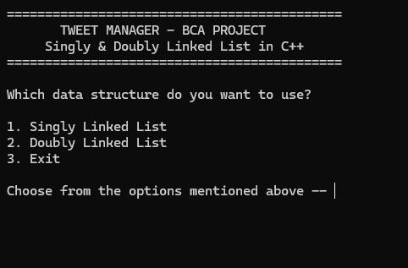

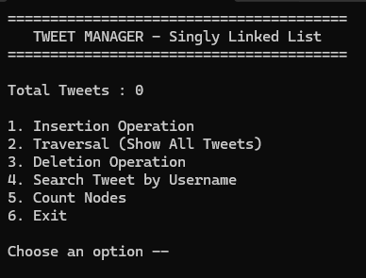

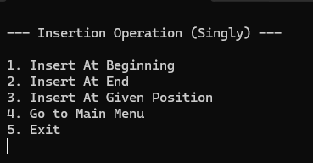

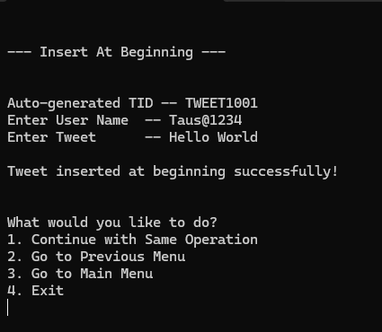

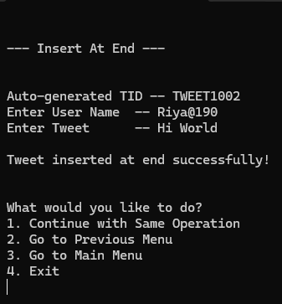

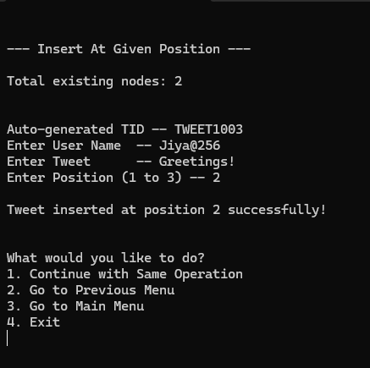

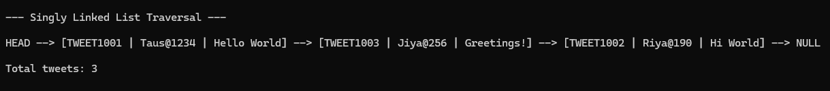

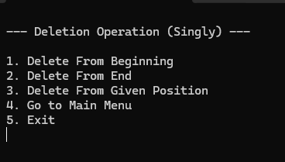
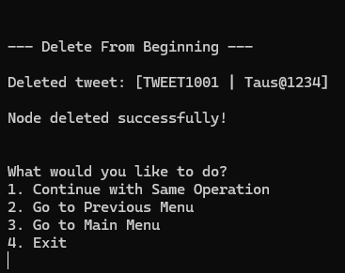

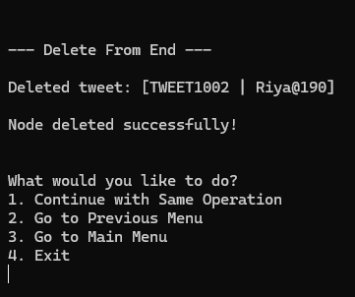

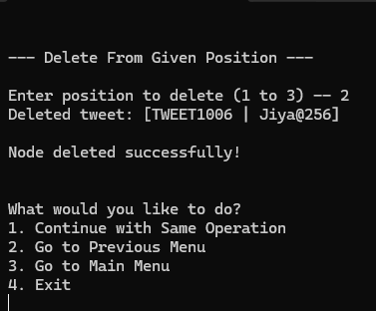

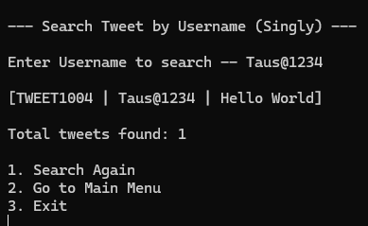

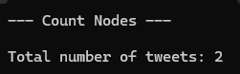

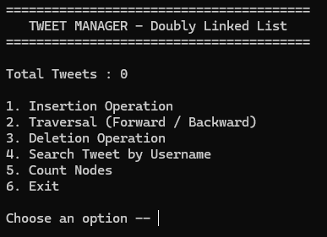

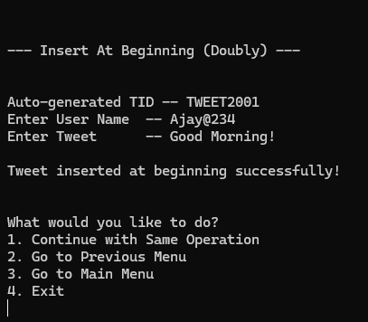

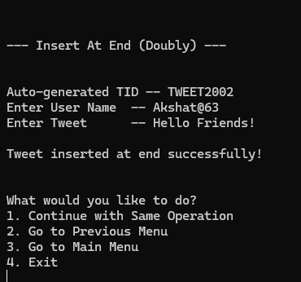

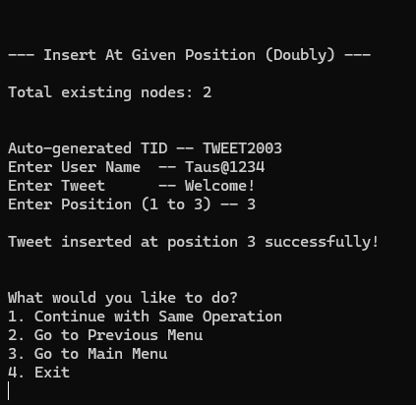

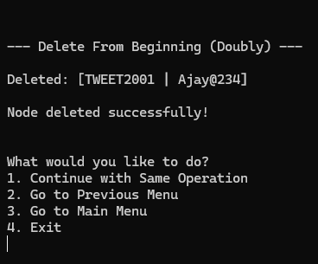

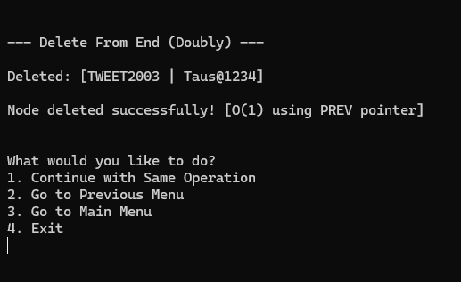

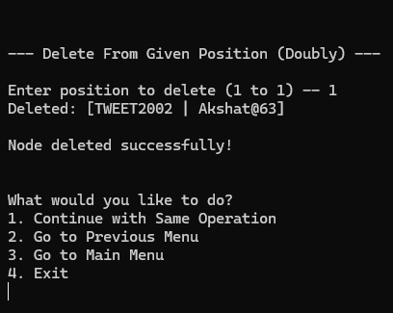

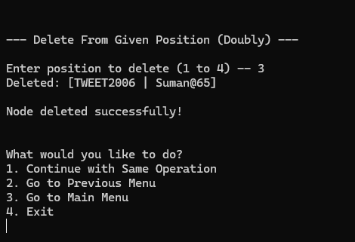

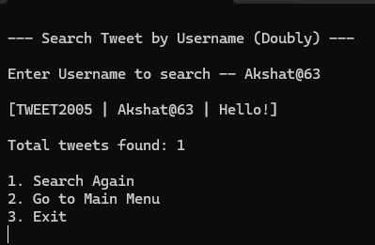

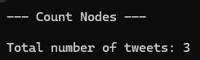

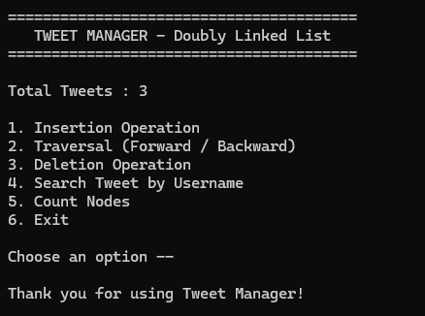

Scan this QR CODE from Further Info !!




` Thank You

